NCC ARMY WING ACTIVITIES 2023-24

TEAM/NAME | EVENT | LEVEL(STATE/NATIONAL/INTERNATIONAL) | AGENCY | ACHIEVEMENT(GOLD/SILVER/BRONZE)
Cadet Lakshita | NCC Republic Day Camp at New Delhi from Dec 29 , 2023 to Jan 28, 2024 | National | DGNCC New Delhi.
12 cadets | Combined Annual Training Camp at LPU Phagwara from July 15-24, 2023. |  | 2 PB (G) BN NCC Jalandhar. | Gold-14  Silver-2  Bronze-9
8 cadets | Combined Annual Training Camp at HMV Jalandhar from Dec 28, 2023 to Jan 6, 2024. |  | 2 PB (G) BN NCC Jalandhar. | Gold-4  Silver-5
SUO Arpandeep  Cadet Lakshita | Ek Bharat Shreshtha Bharat-II at Guntur from June 15-26, 2023. | National | NCC Directorate (AP & T). | Gold-2
Cadet Samiksha | All India Girls Trekking Expedition -2023, from June 7-14, 2023. | National | 5 HP (I) NCC COY Dharamshala Palampur under PHHP&CHD Directorate. | Gold-1
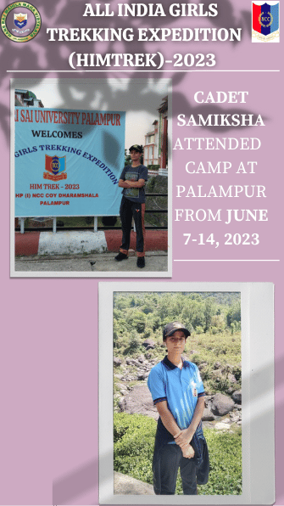
Nationals
- Cadet Samiksha attended ‘All India Girls Trekking Expedition -2023’ from June 7-14, 2023 at Palampur.

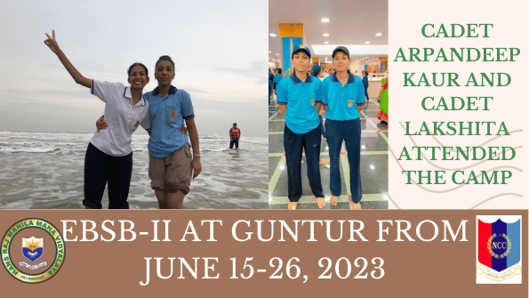
- SUO Arpandeep Kaur and cadet Lakshita attended ‘Ek Bharat Shreshtha Bharat-II’ at Guntur from June 15-26, 2023.

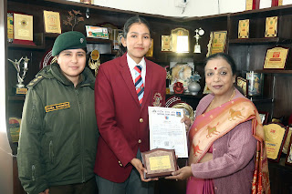
- Cadet Lakshita attended ‘Annual NCC Republic Day Camp’ held at New Delhi from Dec 29 , 2023 to Jan 28, 2024.

Awards and Honours

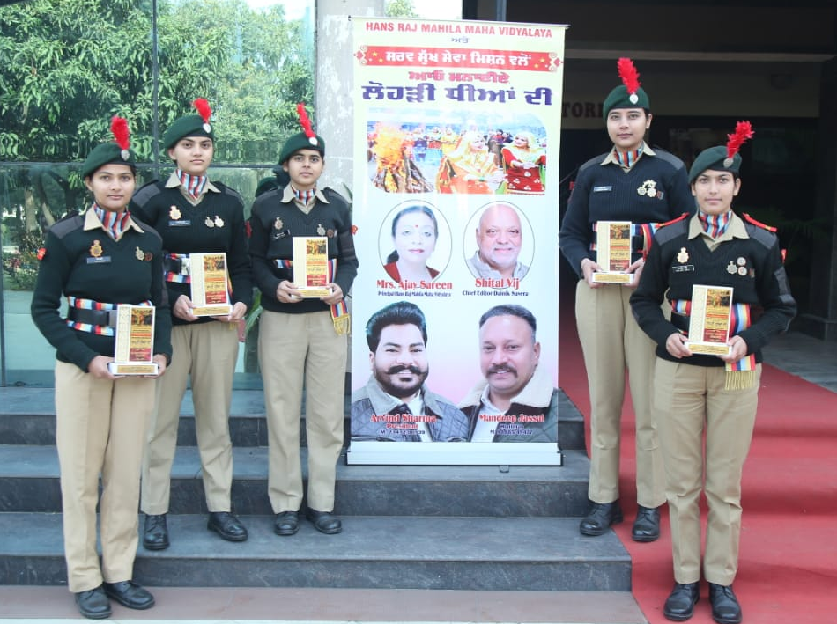
- Five NCC Army Wing Cadets honoured by Sarv Sukh Sewa Mission and Voice of Justice Organisation on celebration of Lohri in collaboration with Hans Raj Mahila Maha Vidyalaya, Jalandhar on Jan 23, 2024.

Camps
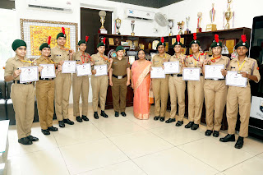
- Army Wing Cadets of Hans Raj Mahila Maha Vidyalaya, Jalandhar attended combined Annual Training Camp (CATC) under 2PB (G) BN NCC, Jalandhar at LPU Phagwara from July 15-24, 2023. 12 cadets of HMV participated in the camp and won 25 medals in different competitions organized during the camp.

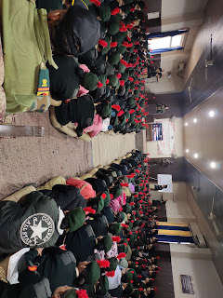
- 2Punjab Girls Battalion NCC Jalandhar organized a ten days CATC camp at Hans Raj Mahila Maha Vidyalaya Jalandhar from Dec 28, 2023 to Jan 6, 2024. Maj Amanpreet Kaur, Adm Officer 2PB ( G) BN NCC told that 360 cadets from 32 different institutions of Jalandhar, Kapurthala and surrounding areas, 7 ANOs, 16 JCOs/ NCOs have reported for attending the camp.

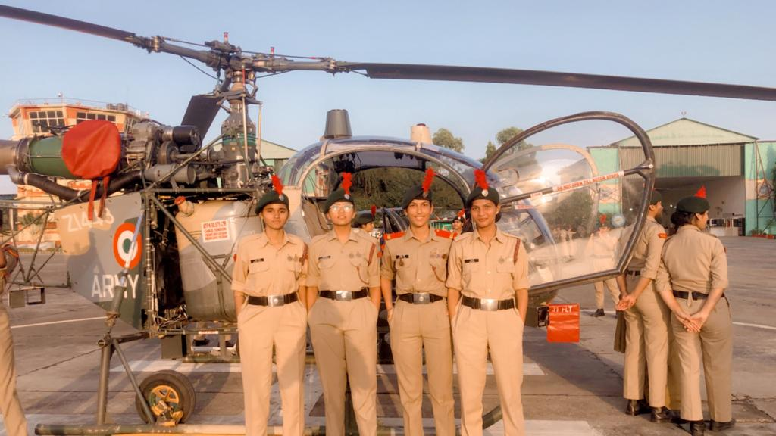
- U/o Baljeet Devi, Cadet Devangi, Cadet Himanshi, Cadet Mehak yadav attended Army Attachment Camp from Oct 09-21, 2023 at 18 Sikh Regiment Jalandhar Cantt.

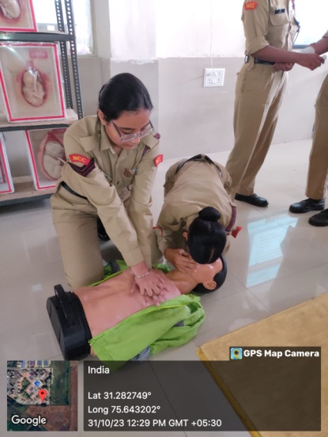
- Cadet Nishat Bano, Sgt Arshdeep Kaur, Cadet Mehak attended Military Hospital Attachment Camp from Oct 28-Nov 08, 2023 at Jalandhar Cantt.

- Cadet Mehak, U/o Baljeet Devi, cadet Nishat Bano, cadet janvi attended CATC-23 at Hoshiarpur under 12 Punjab battalion from June 12-21, 2023.
- Cadet Mehak U/o Baljeet Devi, cadet Nishat Bano, cadet Janvi attended CATC at Hoshiarpur under 2 Punjab Girls battalion from June 23-July 2, 2023.
- Cadet Mehak attended CATC at LPU Phagwara under 1 PB Air Sqd NCC Jalandhar from July 5-July 14, 2023.
- Cadet Lakshita and Cadet Mansi Sharma attended Pre-RDC at DAViet Jalandhar from Oct 13-23, 2023.
Activities
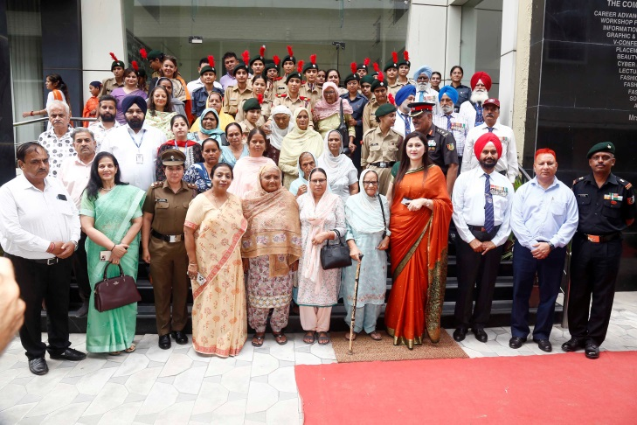
- Kargil Vijay Diwas was Celebrated by NCC Unit of Hans Raj MahilaMahaVidyalaya Jalandhar, in collaboration with Ex-Serviceman Welfare Association Bhogpur, by honouring the Veer Naris on July 26, 2023.

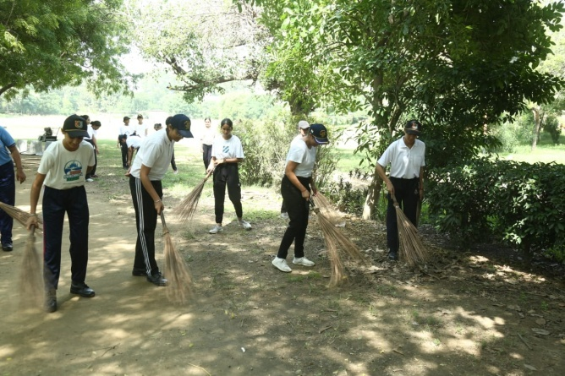

- NCC Army Wing cadets participated in Swachhta Pakhwada organized at HMV Jalandhar on Oct 1, 2023.
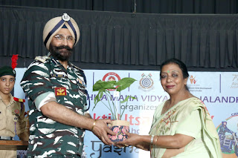
- NCC Unit of Hans Raj Mahila Maha Vidyalaya, Jalandhar organized Shakti-Utsav@HMV in the honour of “Yashasvini: All Women Motorcycle Expedition-2023” in collaboration with CRPF on 12th October,2023.

